Bayesian inference with Stan

- Bayesian inference: an overview
  - Bayes’ anatomy. The goal of Bayesian inference is to adjust our beliefs about some parameter(s) (call it $x$) of a statistical model based on observed data ($y$). We achieve this using Bayes’ rule:

$$p\left(x | y\right)=\frac{p\left(y | x\right)p\left(x\right)}{p\left(y\right)}=\frac{p\left(y | x\right)p\left(x\right)}{\int{p\left(y | x\right)p\left(x\right)d}x}$$

Each term of Bayes’ rule has a specific name. The posterior distribution, $p\left(x | y\right)$, is the thing we’re interested in calculating.

To calculate the posterior distribution, we need a likelihood (or a statistical model), $p\left(y | x\right)$, which specifies how we think our data were generated (i.e., the data’s distribution), assuming some fixed parameter value $x$.

We also need a prior distribution, $p\left(x\right)$. The prior describes what we think about the parameter value before we’ve seen any data.

The evidence, $p\left(y\right)$, is the same as the numerator (the likelihood times the prior) but is integrated over all possible values of $x$ (or summed over all values of $x$, if $x$ is discrete). Often, the evidence is difficult to compute (due to the integral), and so many useful Bayesian methods find clever ways to make it disappear.

  - Example: Estimating the prevalence of malaria-infected mosquitos. Malaria is a disease that is spread to humans through mosquito bites. The disease is caused by a parasite, plasmodium falciparum, which infects the guts of mosquitos and causes havoc in human bloodstreams. To control the spread of malaria, it’s important to know how many mosquitos in a given area are infected by plasmodium.

Imagine we trap and test a single mosquito for plasmodium. What should we believe about the total prevalence of plasmodium-infected mosquitos in our area?

Let $x$ be the true fraction of plasmodium-infected mosquitos – it’s the thing we’re interested in. That is, we’d like to calculate $p\left(x | y\right)$, the posterior distribution, given a single observation $Y = y$, where $y$ might be 0 (uninfected) or 1 (infected).

We might start by defining our statistical model. How does our observation $y$ (whether or not the mosquito is infected) depend on the true prevalence of infected mosquitos $x$? We might imagine that the probability of observing an infected mosquito ($y = 1$) equals the true prevalence of infected mosquitos $x$. That is,

$$P\left(Y=1 | x\right)=x$$
$$P\left(Y=0 | x\right)=1-x$$

In other words,
$$Y∼\text{Bernoulli}\left(x\right)$$
This statistical model is our likelihood. It depends on just one parameter, $x$, the true prevalence of infected mosquitos.

Next, we want to specify our prior belief, $p\left(x\right)$, which is what we believe about the true prevalence of infected mosquitos (the parameter of the statistical model) before making any observations. We might be totally agnostic as to the true fraction of infected mosquitos in the population. There’s no reason for us to think that any one true fraction is more likely than any other, so we use a flat prior, $p\left(x\right)=1$ for $x∈\left[0,1\right]$:

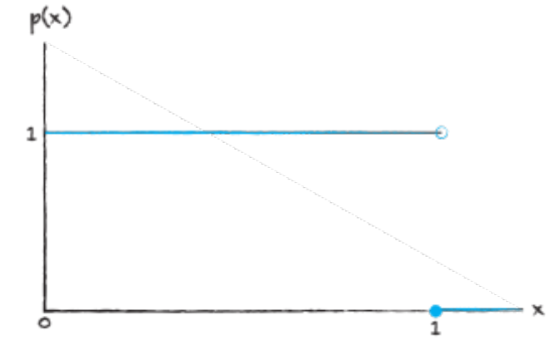

That’s all we need to do our inference! Let’s imagine that we trap one mosquito and it’s infected ($Y = 1$). Note that:

- Given some value of $x$, our likelihood is $P\left(Y=1 | x\right) = x$. This comes from our statistical model.
- Our prior is $p\left(x\right)=1$.
- Our evidence is $P\left(Y=1\right)=\int{P\left(Y=1 | x\right)p\left(x\right)d}x=\int_{0}^{1}{x}⋅1dx=\frac{1}{2}x^{2}{\left.​\right|}_{0}^{1}=\frac{1}{2}$.

Thus, by applying Bayes’ rule, we get:

$$p\left(x | Y=1\right)=\frac{P\left(Y=1 | x\right)p\left(x\right)}{p\left(Y=1\right)}=\frac{x⋅1}{0.5} = 2 x$$

So, our posterior distribution looks like this:

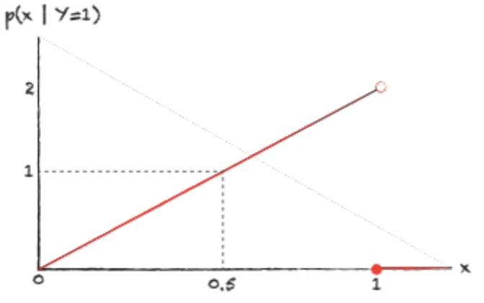

Based on this one data point ($Y = 1$, or one infected mosquito), we have:
- Ruled out the possibility that $x = 0$ (it’s impossible that no mosquitos are infected; we’ve just observed one!)
- Determined that the most likely scenario is that all the mosquitos are infected ($x= 1$)

The most likely scenario is that all the mosquitos are infected!?! Do we really believe that? Well, based on the data alone, this is the most likely scenario; but in reality, it’s exceedingly unlikely that all the mosquitos are infected; that’s just not how plasmodium works. What gives?

Our disbelief at this outcome suggests that maybe our prior was too uncertain! If we truly believe that values near $x = 1$ are unlikely, perhaps it would have been better to choose a prior that looks more like this:

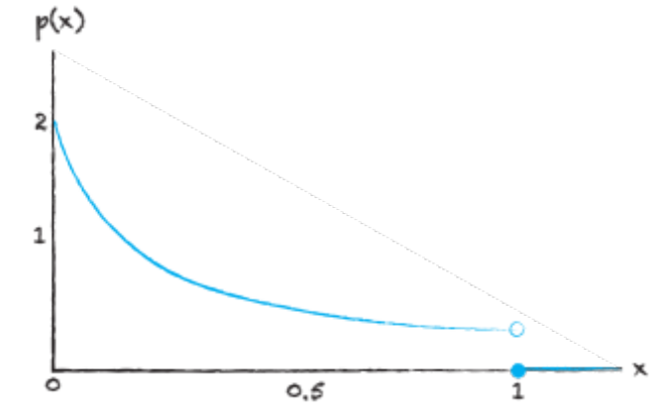

We’ll discuss more about choosing good priors later, but the good news is that the more data we observe, the less the prior matters! After we trap and test many mosquitos, either of the priors shown above should give similar-looking posterior distributions.

  - Incorporating more than one data point. In most situations, we’ll have many data points we’d like to incorporate into our posterior belief. There are two mathematically equivalent ways of doing this, if we can assume that the data are generated independently.

1. Incorporate the data iteratively. Here, we update our posterior distribution for the first data point as in the example above, and then we use that posterior distribution as our new prior distribution for incorporating the next data point, and so on.

2. Incorporate the data all at once. Say we have two observations, $y_{1}$ and $y_{2}$. We can write Bayes’ rule as
$$p\left(x | y_{1},y_{2}\right)=\frac{p\left(y_{1},y_{2} | x\right)p\left(x\right)}{p\left(y_{1},y_{2}\right)}$$

$$=\frac{p\left(y_{1} | x\right)p\left(y_{2} | x\right)p\left(x\right)}{p\left(y_{1}\right)p\left(y_{2}\right)}$$

where the second equality follows from the independence of the three observations. We can show the equivalence of this approach with the approach in (1) by grouping terms:

$$p\left(x | y_{1},y_{2}\right)=\frac{p\left(y_{2} | x\right)p\left(y_{1} | x\right)p\left(x\right)}{p\left(y_{2}\right)p\left(y_{1}\right)}$$

$$=\frac{p\left(y_{2} | x\right)}{p\left(y_{2}\right)}\left[\frac{p\left(y_{1} | x\right)p\left(x\right)}{p\left(y_{1}\right)}\right]$$

The term in brackets is the posterior distribution for $x$ given the single observation $y_{1}$, which then operates like a prior distribution in this last expression when we incorporate $y_{2}$.

- Statistical models
  - Introduction. A statistical model is a mathematical description of the process that generated your data. It takes the form of a probability distribution, with possibly some non-random parts attached. A statistical model usually depends on some parameters, or constants that specify how the model behaves.

The statistical model is the same thing as a likelihood. This means that we can write a model as
$$p\left(y | x\right)=f\left(x\right)$$

where $y$ is the data, $x$ is a parameter, and $f\left(x\right)$ is the specific mathematical formula giving the probability density $p$ of the data $y$ given some parameter value $x$.

In Bayesian inference, we normally treat the statistical model $f$ as something that’s given (that is, something you choose!). Our goal is to learn something about the values of the model’s parameters $x$ based on the data $y$.

We’ll now introduce a few types of statistical models that commonly arise in Bayesian inference.

  - Pure distributional models. The simplest type of model takes the form of a single, named probability distribution, like a Bernoulli or a Normal distribution. In the “mosquitos” example above, our statistical model was a pure distributional model:

$$p\left(y | x\right)∼\text{Bernoulli}\left(x\right)$$

Alternatively, we might be interested in modeling the heights $y$ of individuals in a population. We might model this as
$$p\left(y | μ,σ\right)∼\text{Normal}\left(μ,σ\right)$$

Where $μ$ is the mean height and $σ$ is the standard deviation of heights. Here, both $μ$ and $σ$ are parameters of the model, and we might be interested in estimating values for both.

  - Mixture models. Sometimes, it’s helpful to combine multiple named probability distributions to get more complex models. For example, if males and females have different mean heights, we might model the heights in a population of 80% females and 20% males as

$$p\left(y | μ_{f},σ_{f},μ_{m},σ_{m}\right)=0.8×\text{Normal}\left(μ_{f},σ_{f}\right)+0.2×\text{Normal}\left(μ_{m},σ_{m}\right)$$

A mixture model like this one could look something like:

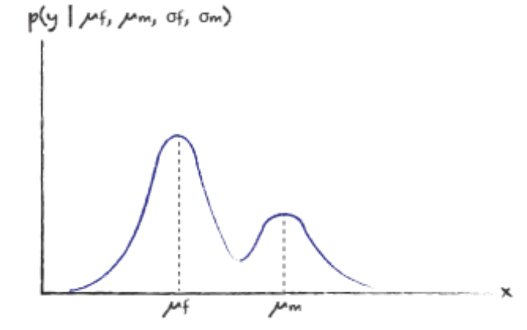

  - Models with deterministic bits attached. Sometimes, it’s useful to define a statistical model that includes some non-random elements. An especially common use case for this type of model is when you envision a deterministic “signal” with random “noise”. For example, a statistical model for standard linear regression might look like:

$$p\left(y_{t} | β_{0},β_{1},σ\right)∼β_{0}+β_{1}t+\text{Normal}\left(0,σ\right)$$

According to this model, $y_{t}$ is positioned at the value $β_{0}+β_{1}t$ (a straight line with intercept $β_{0}$ and slope $β_{1}$) with some additional measurement error, where the error has standard deviation $σ$.

  - Hierarchical (compound) models. A hierarchical statistical model is one where the parameters of the model themselves may have distributions of their own. These types of models are especially useful for ecological applications, where organisms tend to belong to nested sets of biological communities.

A common example for this type of model is to compare salaries in different departments across a university. Within a department $d$, we might expect the salaries to be Normal-distributed:
$${p(y}_{d,i}\left|μ_{d},σ_{d}\right)∼\text{Normal}\left(μ_{d},σ_{d}\right)$$

Here, $y_{d,i}$ is the salary for person $i$ in department $d$. We might also expect the mean salaries themselves to follow some distribution, related to the overall mean salary across the entire university:

$${p(μ}_{d}\left|μ_{\text{overall}},σ_{\text{overall}}\right)∼\text{Normal}\left(μ_{\text{overall}},σ_{\text{overall}}\right)$$

Likewise, the different departments might have different widths of their salary range, so perhaps

$${p(σ}_{d}\left|α,β\right)∼\text{Lognormal}\left(α,β\right)$$

I chose a Lognormal distribution here because it’s defined on the positive real numbers, and we need $σ_{d}$ to be positive.

This is why these models are often called hierarchical: we have a statistical model describing the data-generating process ($p\left(y_{d,i} | μ_{d},σ_{d}\right)$), but then we also have additional statistical models describing the parameters of the data-generating process ($p\left(μ_{d} | μ_{\text{overall}},σ_{\text{overall}}\right)$ and $p\left(σ_{d} | α,β\right)$). We often refer to the parameters of the data-generating process ($μ_{d}$, $σ_{d}$) as simply “parameters”, and to any parameters pertaining to statistical models of these parameters (that is, $μ_{\text{overall}}$, $σ_{\text{overall}}$, $α$, and $β$) as hyperparameters.

When conducting Bayesian inference on a hierarchical model, we only need to specify priors for the top-level hyperparameters; everything else flows from there.

The following figure depicts what’s going on with the hierarchical model for salaries, using the example of three departments d (English, Mathematics, and Chemistry):

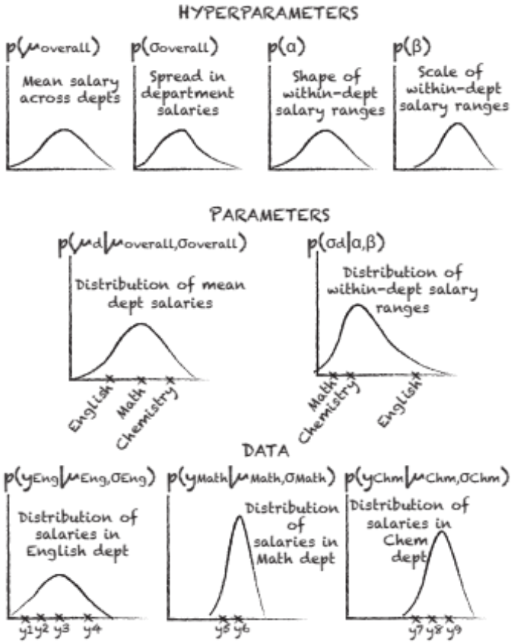

Let’s break this figure down. It’s easiest to think of hierarchical models from bottom to top. On the lowest level (“Data”), we have three distributions, one for each of the departments (English, Math, and Chemistry). These are the data-generating distributions, the ones from which the observed salaries are presumably drawn. The first distribution describes the salaries of individual members of the English department, for which we have four observations $\left(y_{1},…,y_{4}\right)$. The second describes the salaries of individual members of the Math department, for which we have two observations ($y_{5},y_{6}$). The third describes the salaries of individual members of the Chemistry department, for which we have three observations ($y_{7},…,y_{9}$). These distributions differ in some important ways: they have different means (the average salary is highest for Chemistry and lowest for English), and they also have different spreads (the width of the distribution for Math is smaller than for Chemistry or English).

How are these distributions related to one another? The middle level, titled “Parameters”, shows us. At this level, we see that the mean salaries in each department come from some common distribution (left-hand plot) and the spreads of the salaries in each department come from a different common distribution (right-hand plot).

Why go through the trouble of specifying distributions for the parameters? Why not just separately estimate $μ_{Eng}$, $σ_{Eng}$, $μ_{Math}$, $σ_{Math}$, $μ_{Chem}$, and $σ_{Chem}$, based on the data from those departments?

There’s nothing inherently wrong with this approach, and sometimes it will give us all the answers we need. But using a hierarchical model – incorporating the “Parameters” level – has two advantages:

- It gives us a useful way of describing variation between departments, in addition to describing the variation between individuals within a department. In other words, if the system we’re trying to describe has multiple levels of organization (in this case, these levels are “individual” and “department”), a hierarchical model transparently describes what’s going on at each level.
- It allows us to share information between subsets of the population. For example: imagine we had lots of data from the English and Chemistry departments, but very little from Math. Without a hierarchical model, we wouldn’t be able to say much about the distribution of salaries from the Math department. However, by using a hierarchical model, the data from the English and Chemistry departments inform the distributions at the "Parameters” (middle) level, which in turn can refine our belief about what’s going on in the Math department.

Finally, we need to account for the highest level of the model, the “Hyperparameters” level. These are the things that we need to set priors for. These distributions capture the mean and spread of the department-level means (first two plots), and the shape and scale parameters of the department-level spreads (second two plots). In this hierarchical model, the parameters (middle level) are treated as draws from distributions that are defined by the hyperparameters (top level); and the data (bottom level) are treated as draws from the distributions defined by the parameters (middle level).

- MCMC for Bayesian inference
  - Monte Carlo methods. A Monte Carlo method is a method that uses random numbers to simplify a challenging math problem. The most basic Monte Carlo methods use random draws from a probability distribution (e.g., a Normal distribution) to help us quickly access useful summaries of that distribution (e.g., using a histogram to visualize its shape; calculating the empirical mean and standard deviation to estimate the true mean and standard deviation; finding the middle 95% of draws to summarize a 95% credible interval).

  - Monte Carlo methods for sampling from challenging distributions. A common task for Monte Carlo methods is to generate pseudo-random samples as if they came from a “challenging” distribution. Generating samples from a distribution is in general a challenging task – the convenient functions like rnorm() and runif()hide the huge amount of mathematics needed to create random-seeming numbers that appear as if they came from a Normal or Uniform distribution!

To generate random numbers from more complex distributions, we generally need to start with numbers generated from these simpler distributions, and then adjust these draws to make them align better with the distribution we’re trying to approximate. There are many ways to achieve this; see, for example, the inverse CDF method and rejection sampling. The inverse CDF method and rejection sampling are examples of Monte Carlo algorithms that are not Markov Chain algorithms. They use random draws to simplify a challenging problem, but the draws themselves are independent from one another.

In general, each Monte Carlo algorithm involves some tradeoff between efficiency and complexity. The inverse CDF method is highly efficient, but it requires you to be able to compute the inverse of the CDF, which might be a challenging or impossible math problem. Rejection sampling doesn’t require any inversion, so it’s less complex; but it does require you to find some function that you can sample from that is also greater than your target distribution at every point – which can be challenging to prove. It’s also less efficient than the inverse CDF method because many proposed draws might get thrown away.

Markov Chain Monte Carlo (MCMC) methods lie at the opposite end of the spectrum from the inverse CDF method: they’re simple, but relatively inefficient. Because of this, MCMC method weren’t used much until fast computers became available. Now, though, we have superfast computers, which makes MCMC algorithms an excellent choice for many problems.

Most MCMC algorithms (for computing facts about a target probability distribution) involve a few steps:
- Initialization: the “starting point” for the Markov Chain is chosen, sometimes completely arbitrarily
- Jump/Proposal: A new “proposal” point is chosen according to some random jump from the initial point.
- Acceptance/Rejection: The proposed point is accepted or rejected according to some acceptance criterion, usually related to the ratio of the target probability density at the new point vs. the old point. If the proposed point is rejected, the old point is accepted instead.
The algorithm then repeats for some acceptable (high!) number of iterations.

The path-dependence of MCMC algorithms – in that each new proposal is usually just a small perturbation from the most recently accepted value – is what makes the algorithms inefficient. However, by running the algorithm for enough iterations, a well-designed algorithm (like the Metropolis algorithm) is guaranteed to give us draws that behave as if they came directly from the target distribution. So, if we have a reasonably fast computer, we’re usually in good shape!

- Structure of Stan code
- Examples

